Project Planning Phase
Project Planning Template (Product Backlog, Sprint Planning, Stories, Story points)

Date | 12 NOVEMBER 2022
Team ID | PNT2022TMID01033
Project Name | Classification Of Arrhythmia By Using Deep Learning With 2-D ECG Spectral Image Representation

Product Backlog, Sprint Schedule, and Estimation
Use the below template to create product backlog and sprint schedule
Sprint | Functional Requirement (Epic) | User Story Number | User Story / Task | Story Points | Priority | Team Members
Sprint-1 | Data Collection | USN-1 | Collect the Dataset from various sources | 9 | High | Kalaiselvi S
Sprint-1 |  | USN-2 | Process the images in the dataset for better accuracy [Image processing and Augmentation] | 8 | Medium | Kalaiselvi S
Sprint-2 | Model Building | USN-3 | Import the necessary libraries and then initialize the model | 8 | Medium | Kanishya A
Sprint-2 |  | USN-3 | Necessary libraries are added and then the model is trained using CNN | 10 | High | Kanishya A
Sprint-3 | Training and Testing | USN-4 | The model is trained and tested for accuracy and then accurate model is saved | 9 | High | Bhuvana
Sprint-4 | Application Building | USN-5 | The HTML files are created ,Python codes are built and then finally the app is made to run | 8 | Medium | Kiruthika V

Project Tracker, Velocity & Burndown Chart: (4 Marks)
Sprint | Total Story Points | Duration | Sprint Start Date | Sprint End Date (Planned) | Story Points Completed (as on Planned End Date) | Sprint Release Date (Actual)
Sprint-1 | 10 | 6 Days | 24 Oct 2022 | 29 Oct 2022 | 7 | 12 Nov 2022
Sprint-2 | 10 | 6 Days | 31 Oct 2022 | 05 Nov 2022 | 7 | 12 Nov 2022
Sprint-3 | 10 | 6 Days | 07 Nov 2022 | 12 Nov 2022 | 10 | 12 Nov 2022
Sprint-4 | 10 | 6 Days | 14 Nov 2022 | 19 Nov 2022 | 10 | 19 Nov 2022

Average Velocity:
AV = Velocity/Sprint Duration
=10/6
=1.666

Burndown Chart:
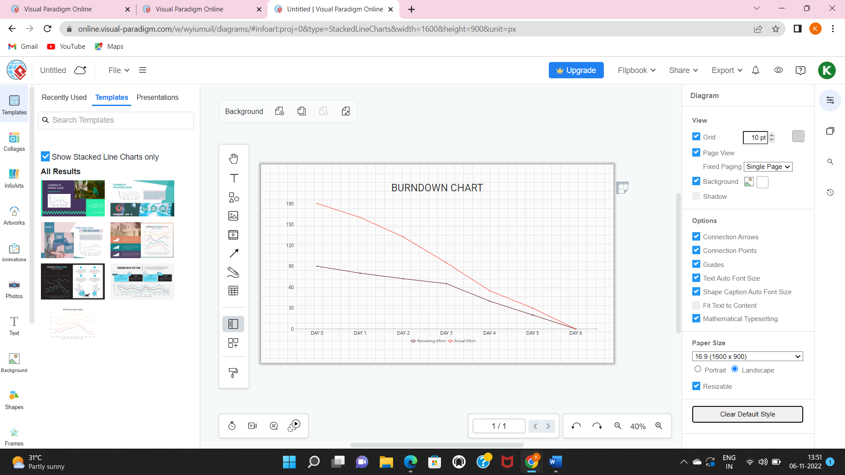

SPRINT BURNDOWN CHART
